Grove - Infrared Receiver

|  |
| --- |
| **Contents**   [[hide](javascript:toggleToc())]   * [1 Introduction](http://www.seeedstudio.com/wiki/Grove_-_Infrared_Receiver#Introduction) * [2 Features](http://www.seeedstudio.com/wiki/Grove_-_Infrared_Receiver#Features) * [3 Application Ideas](http://www.seeedstudio.com/wiki/Grove_-_Infrared_Receiver#Application_Ideas) * [4 Mechanic Dimensions](http://www.seeedstudio.com/wiki/Grove_-_Infrared_Receiver#Mechanic_Dimensions) * [5 Usage](http://www.seeedstudio.com/wiki/Grove_-_Infrared_Receiver#Usage)   + [5.1 Hardware Installation](http://www.seeedstudio.com/wiki/Grove_-_Infrared_Receiver#Hardware_Installation)   + [5.2 Programming](http://www.seeedstudio.com/wiki/Grove_-_Infrared_Receiver#Programming) * [6 Support](http://www.seeedstudio.com/wiki/Grove_-_Infrared_Receiver#Support) * [7 Version Tracker](http://www.seeedstudio.com/wiki/Grove_-_Infrared_Receiver#Version_Tracker) * [8 Resources](http://www.seeedstudio.com/wiki/Grove_-_Infrared_Receiver#Resources) * [9 How to buy](http://www.seeedstudio.com/wiki/Grove_-_Infrared_Receiver#How_to_buy) * [10 See Also](http://www.seeedstudio.com/wiki/Grove_-_Infrared_Receiver#See_Also) * [11 Licensing](http://www.seeedstudio.com/wiki/Grove_-_Infrared_Receiver#Licensing) |

Introduction

The Infrared Receiver is used to receive infrared signals and also used for remote control detection. There is a IR detector on the Infrared Receiver which is used to get the infrared light emitted by the Infrared Emitter. The IR detector have a demodulator inside that looks for modulated IR at 38 KHz. The Infrared Receiver can receive signals well within 10 meters. If more than 10 meters , the receiver may not get the signals. We often use the two Groves-the Infrared Receiver and the [Grove - Infrared Emitter](http://www.seeedstudio.com/wiki/Grove_-_Infrared_Emitter) to work together.

**Model:**[**WLS12136P**](http://www.seeedstudio.com/depot/grove-infrared-receiver-p-994.html?cPath=139_204)

[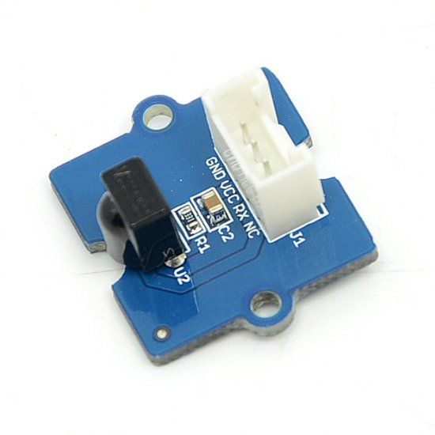](http://www.seeedstudio.com/wiki/File:Grove_-_Infrared_Receiver.jpg)

Features

* Grove compatible interface
* Supports 3.3V and 5V supply voltages.

Application Ideas

* Remote Control of robots, relays or other things

Mechanic Dimensions

20mm by 24mm

Usage

**Hardware Installation**

Connect the Transmitter module to Digital I/O 10 of the [Grove - Base Shield](http://www.seeedstudio.com/wiki/Grove_-_Base_Shield) on the receiving arduino.

**Programming**

The demo below is the IRrecvDemo.pde example provided by the IRremote library.

Download [IRremote.zip](http://arcfn.com/files/IRremote.zip) and unpack into arduino/hardware/libraries in your arduino installation.

/*

* IRremote: IRrecvDemo - demonstrates receiving IR codes with IRrecv

* An IR detector/demodulator must be connected to the input RECV_PIN.

* Version 0.1 July, 2009

* Copyright 2009 Ken Shirriff

* http://arcfn.com

*/

#include <IRremote.h>

**int** RECV_PIN = 11;

IRrecv irrecv(RECV_PIN);

decode_results results;

**void** **setup**()

{

**Serial**.begin(9600);

irrecv.enableIRIn(); // Start the receiver

}

**void** **loop**() {

**if** (irrecv.decode(&results)) {

**Serial**.println(results.value, **HEX**);

irrecv.resume(); // Receive the next value

}

}

Support

[Ask questions on Seeed forum](http://www.seeedstudio.com/forum).

Version Tracker

|  |  |  |
| --- | --- | --- |
| **Revision** | **Descriptions** | **Release** |
| v0.9b | Initial public release | 04,Oct,2011 |

Resources

* Eagle files: [File:Twig - Infrared Receiver v0.9b.zip](http://www.seeedstudio.com/wiki/File:Twig_-_Infrared_Receiver_v0.9b.zip)
* Schematic (PDF): [File:Twig - Infrared Receiver v0.9.pdf](http://www.seeedstudio.com/wiki/File:Twig_-_Infrared_Receiver_v0.9.pdf)
* [IRremote arduino library](http://arcfn.com/files/IRremote.zip)
* [IRremote arduino library documentation](http://www.arcfn.com/2009/08/multi-protocol-infrared-remote-library.html)
* [TSOP282 Datasheet](http://www.vishay.com/docs/81733/tsop382.pdf)